Intro to Calc Rational Function Review Name:

I Simplify each complex expression

1. (7 + 5i) – (-4 – 3i) 2. 3i(2i – 7) – 5i(i + 4)

11 + 8i -1 – 41i

3.  4. 

-24 + 2i -44 + 6i

5.  6. 

7.  8. 

2 + i

II Polynomial Review

For each polynomial, find all real and imaginary zeros of the function and state their multiplicity.

9. f(x) = 2x5 – 8x4 +12x3 – 8x2 10. f(x) = 6x6 – 27x5 + 66x4 – 90x3

GCF: 2x2(x3 – 4x2 + 6x – 4) GCF: 3x3(2x3 – 9x2 + 22x – 30)

Poss Rational roots: ±1, 2, 4 Poss Rational roots: ±1, 2, 3, 5, 6, 10, 15, 30, ½, 3/2, 5/2, 15/2

Poss + real roots: 3 or 1 Poss + real roots: 3 or 1

Poss – real roots: none Poss – real roots: none

Synthetic Div: Synthetic Div:

2 ┘ 1 -4 6 -4 5/2 ┘ 2 -9 22 -30

2 -4 4 5 -10 30

1 -2 2 0 2 4 12 0

New factored: 2x2(x – 2)(x2 – 2x + 2) New factored form: 3x3(x – 5/2)(2x2 – 4x + 12)

Quad formula on quadratic yields: Quad formula yields:

2x2 ( x – 2) (x - (1 + i))(x - (1 – i)) 3x3(x – 5/2)(x – (1 + i $\sqrt{5}$))(x – (1 – i $\sqrt{5}$))

**ROOTS: 0 (mult of 2), 2, 1±i ROOTS: 0 (mult of 3), 5/2, 1 ± i $\sqrt{5}$**

III Rational functions. For each rational function, state any holes, intercepts and asymptotes and then graph accurately each, labeling the holes, intercepts and asymptotes.

11.  12. 

Hole: none Hole: none

x-int: x = 5 x-int: x = -1

y-int: y = 5/8 y-int: y = 1/12

HA: y = 0 HA: y = 0

SA: none SA: none

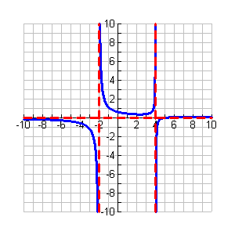VA: x = 4 and x = -2 VA: x = 3 and x = 4

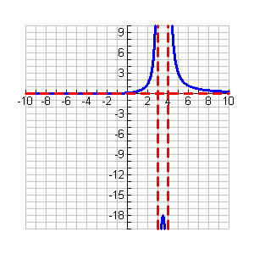

13.  14. 

Hole: x = -3 Hole: x = 2

x-int: x = 1/2 x-int: x = -1/4

y-int: y = -1/3 y-int: y = 1/3

HA: y = 1/2 HA: y = 2

SA: none SA: none

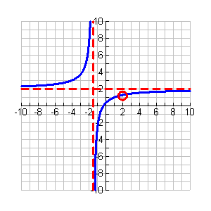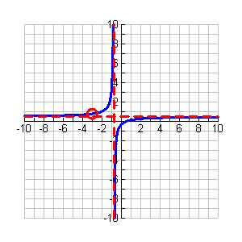VA: x = -3/4 VA: x = -3/2

1.  16. 

Hole: none Hole: none

x-int: x = -3 and x = -4 x-int: x = -5 and x = -3

y-int: y = 12/25 y-int: y = -5/2

HA: y = 1 HA: y = 1

SA: none SA: none

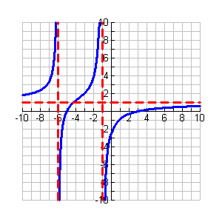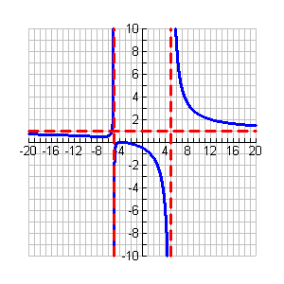VA: x = 5 and x = -5 VA: x = -1 and x = -6

17.  18. 

Hole: x = 1 Hole: none

x-int: x = 4 and x = 0 x-int: x = 0 and x = -8 and x = -3

y-int: y = 0 y-int: y = 0

HA: none HA: none

SA: y = x – 5 SA: y = x + 13

VA: x = -1 VA: x = 1

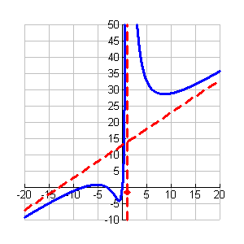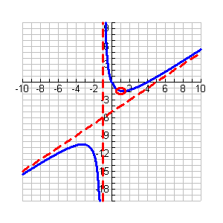

19.  20. 

Hole: x = 1 Hole: none

x-int: x = 4 and x = 0 x-int: x = 0 and x = -8 and x = -3

y-int: y = 0 y-int: y = 0

HA: none HA: none

SA: y = x – 5 SA: y = x + 13

VA: x = -1 VA: x = 1

