Name:_________________________________________
Unit 1 LT 2 Retake 1 Assignment (2.2 – 2.3)

- Use the table of values to help calculate the derivative of each function at the given point. If there is not enough information be sure to state why in your answer.
 | x = 1 | x = 2 | x = 3 | x = 4 | x = 5 | x = 6 | x = 7
f(x) | 2 | -3 | 5 | 1 | 7 | 8 | 9
f ‘ (x) | 0 | -3 | 4 | -6 | 2 | 5 | -5
g(x) | 3 | 8 | -1 | 0 | 6 | 2 | 1
g’(x) | 4 | 1 | -9 | 2 | 5 | 3 | 2

a) 2f(x)+g(x) when x = 2 b) f(x)g(x) when x = 7

c) $\frac{f(x)}{g(x)}$ when x = 1

Use the graph below to find the derivative of h(x) at the given value.

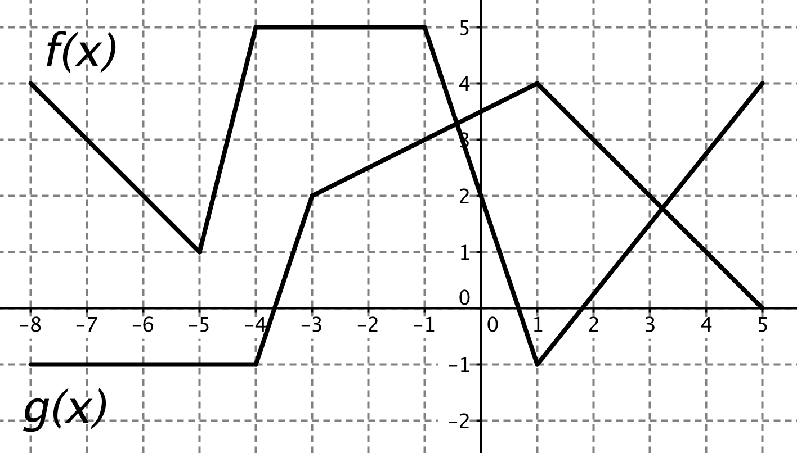

a) h(x) = -4f(x) when x = 0 b) $h\left(x\right)=f\left(x\right)g(x)$ when x = 3

c) $h\left(x\right)=\frac{f\left(x\right)}{g\left(x\right)}$ when x = -6 d) $h\left(x\right)=2f\left(x\right)+f\left(x\right)g\left(x\right)$ when x = 2

e) $h\left(x\right)=f\left(x\right)-g(x)$ when x = -1
Please do the following problems from the book:

p. 115# 8-22 even

p. 126# 6-12 even, 44, 50, 54, 63

